
3P Technik
TC320/330/340 Tank Level Controller

Installation and Operating Manual
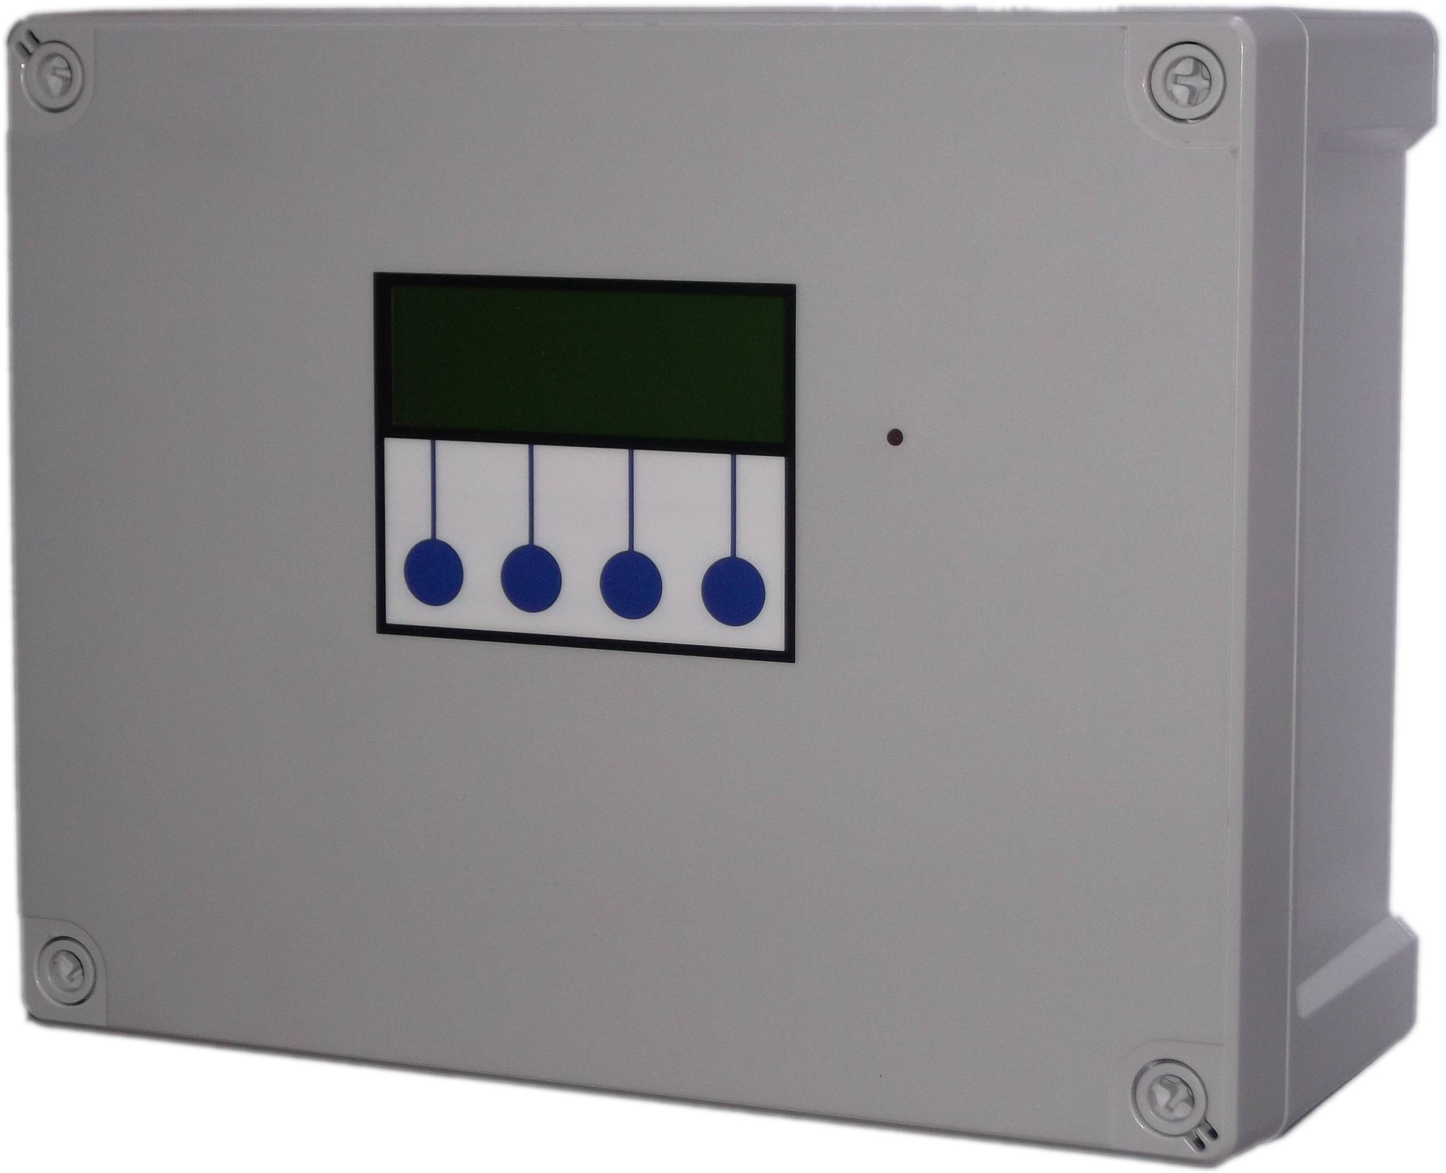

Table of Contents
Safety 3
Installation 3
Included Components 3
Layout 4
Control Panel Mounting 6
Mains Power Connection 6
Output Power Connections 7
Switch Input Connections 7
Tank Level Sensor Connections 7
BMS connection 7
Troubleshooting 7
Fuse Listing 9
Inputs (left to right) – Con1 9
Pressure Sensor Inputs (left to right) 9
BMS Output 10
Output Control Outputs (left to right) 10
Upgrades and Modifications 10
Specifications 11
Control Panel 11
Tank Level Sensor 11
Switched Outputs (pump/solenoid/valve control) 11
Operation 12
Description of Operation 12
Control Panel Operations 13
Menus and Functions 13
Water Level Display 14
Accessing the Menu Options 14
Status Screen 14
Main Menu 14
Setup Menu (Menu>Setup) 14
Virtual Output Setup (Menu>Setup>Virtual) 14
Output Setup (Menu>Setup>Outputs) 15
Main Functions 15
Virtual Input Selection 15
Levels 15
Duty Cycle 15
Output Configuration Examples 16
Tank Alarms (Menu>Setup>Alarms) 17
Fault Diagnosis 17
Diagnostic Menu (Menu>Diags) 17
Input Options (Menu>Diags>Inputs) 17
View Inputs (Menu>Diags>Inputs>View Input) 17
Adjust Probe Stability (Menu>Diags>Inputs>Adjust Probe Stability) 18
Activate Outputs (Menu>Diags>Outputs) 18
View Logged Fault Codes (Menu>Diags>Faults) 19
TC Series Fault Codes (all models) 19
Clear Logged Fault Codes (Menu>Diags>Faults>Clear) 21
Run 21
Stop 21
Menu (Stop>Menu) 21
Wipe Configuration (Stop>Wipe Config) 22
Restart (Stop>Restart) 22
Troubleshooting 22
Fuse Listing 23
Inputs (left to right) – Con1 24
Pressure Sensor Inputs (left to right) 26
BMS Output (con5) 26
Outputs (left to right) 26
Upgrades and Modifications 27
Specifications 28
Control Panel 28
Tank Level Sensor 28
Switched Outputs (pump/solenoid control) 28

Safety
Mains Voltage – There are exposed electrical conductors inside this appliance. This appliance must be installed and serviced by a competent electricical technician to the current requirements of BS7671 and IEEE recommendations.

Before servicing this appliance, normal safe isolation procedures should be implemented.

Do not touch the PCB while energised, it carries mains voltage.

Do not touch any connection terminals while energised.

Do not attempt to service this item when wet, or in a wet or high humidity environment.

If the housing of the control panel becomes damaged, you must shut down and securely isolate this appliance immediately.

You must connect this appliance to a grounded 3 wire supply, protected by suitable overload protection. Connected pumps and solenoids are earthed via the control panel, and may otherwise become live.

If the power cables are damaged, either to of from the controller then shut down and isolate this apliance.

The combined loading of pumps, etc. connected t this appliance must not exceed 20A using the supplied mains flex. Contact the manufacturer for advice if you need to exceed this rating.

Do not attempt to repair any part of the circuit board. Refer to the manufacturer for advice.

Installation

Included Components
1 x Control Panel
1 x 2m Mains Flex 2.5mm
Cable Glands (qty depending on model)
1 x Pressure transmitter with 20m cable
Optional - 2nd Pressure transmitter with 20m cable

Layout
Unlike a pressure based controller, the 3P TC Series Tank Controller does not contain any plumbing. This means you can install the control panel anywhere you wish within the building.

You will need to consider the following constraints,

The control panel cannot be mounted outside, it is not weather resistant (although can be made weather resistant – call us for advice)

Voltage drop will affect the cable size needed to take power to your pumps. Over very long runs, you may find it more economical to install contactors near to the pumps, allowing you to control the pumps with a sensible cable size. It is strongly recommended that you calculate voltage drop for cable runs in excess of 20m. Failure to do so may result in faulty operation, cable overheating, conductor migration, and risk of fire. The same caution applies to solenoid valves, although the current draw is usually so small that only extreme distances are likely to present a problem.

Also note that all control cabling (sensor and switch wiring) beyond a few metres and installed in electrically noisy environments may need to be shielded to avoid false switch detection or unstable level readings.

Note – it is recommended that you earth the shielding on cables (where present) to an earth terminal within the controller. Do not earth to DC 0v as the DC power supply is isolated and will not function as a ground.

Do not install control cabling next to mains power cables, particularly over long distances. Adequate separation from power cables will reduce potential problems. Where control cabling must cross mains wiring it should be done at right angles and kept to a minimum.

We do not make any recommendation as to the specific cable or layout to be used. It is the responsibility of the installer to install control cabling appropriately giving consideration to length and proximity to electromagnetic noise.

It is expected that the installer is suitably competent with regard to electrical installation, and the provisions of and testing in accordance with the current regulations in force in your area. It is also expected that the installer is competent to install, validate and resolve any issues with regard to control cabling.

In the event of unresolved interference to switch inputs, it is possible to create a separate powered sensor circuit at low voltage operating relays near to the control panel to act as inputs. This will have much higher immunity to parasitic voltages than the transistor based inputs on the control panel.

Most instability of the level sensor caused either by interference or turbulence in the water itself can be compensated in software by adjustment of the probe stability setting.

Pressure transmitter cable is of a special type incorporating a vent tube to equalise the pressure within the transmitter to atmospheric pressure (3P part no. IRVENT or IRVENTX depending on type). The vent should terminate in a dry location. If not then it must be extended in vented cable to a suitable location, or terminated in a sealed box with moisture resistant breather plug.

Control Panel Mounting
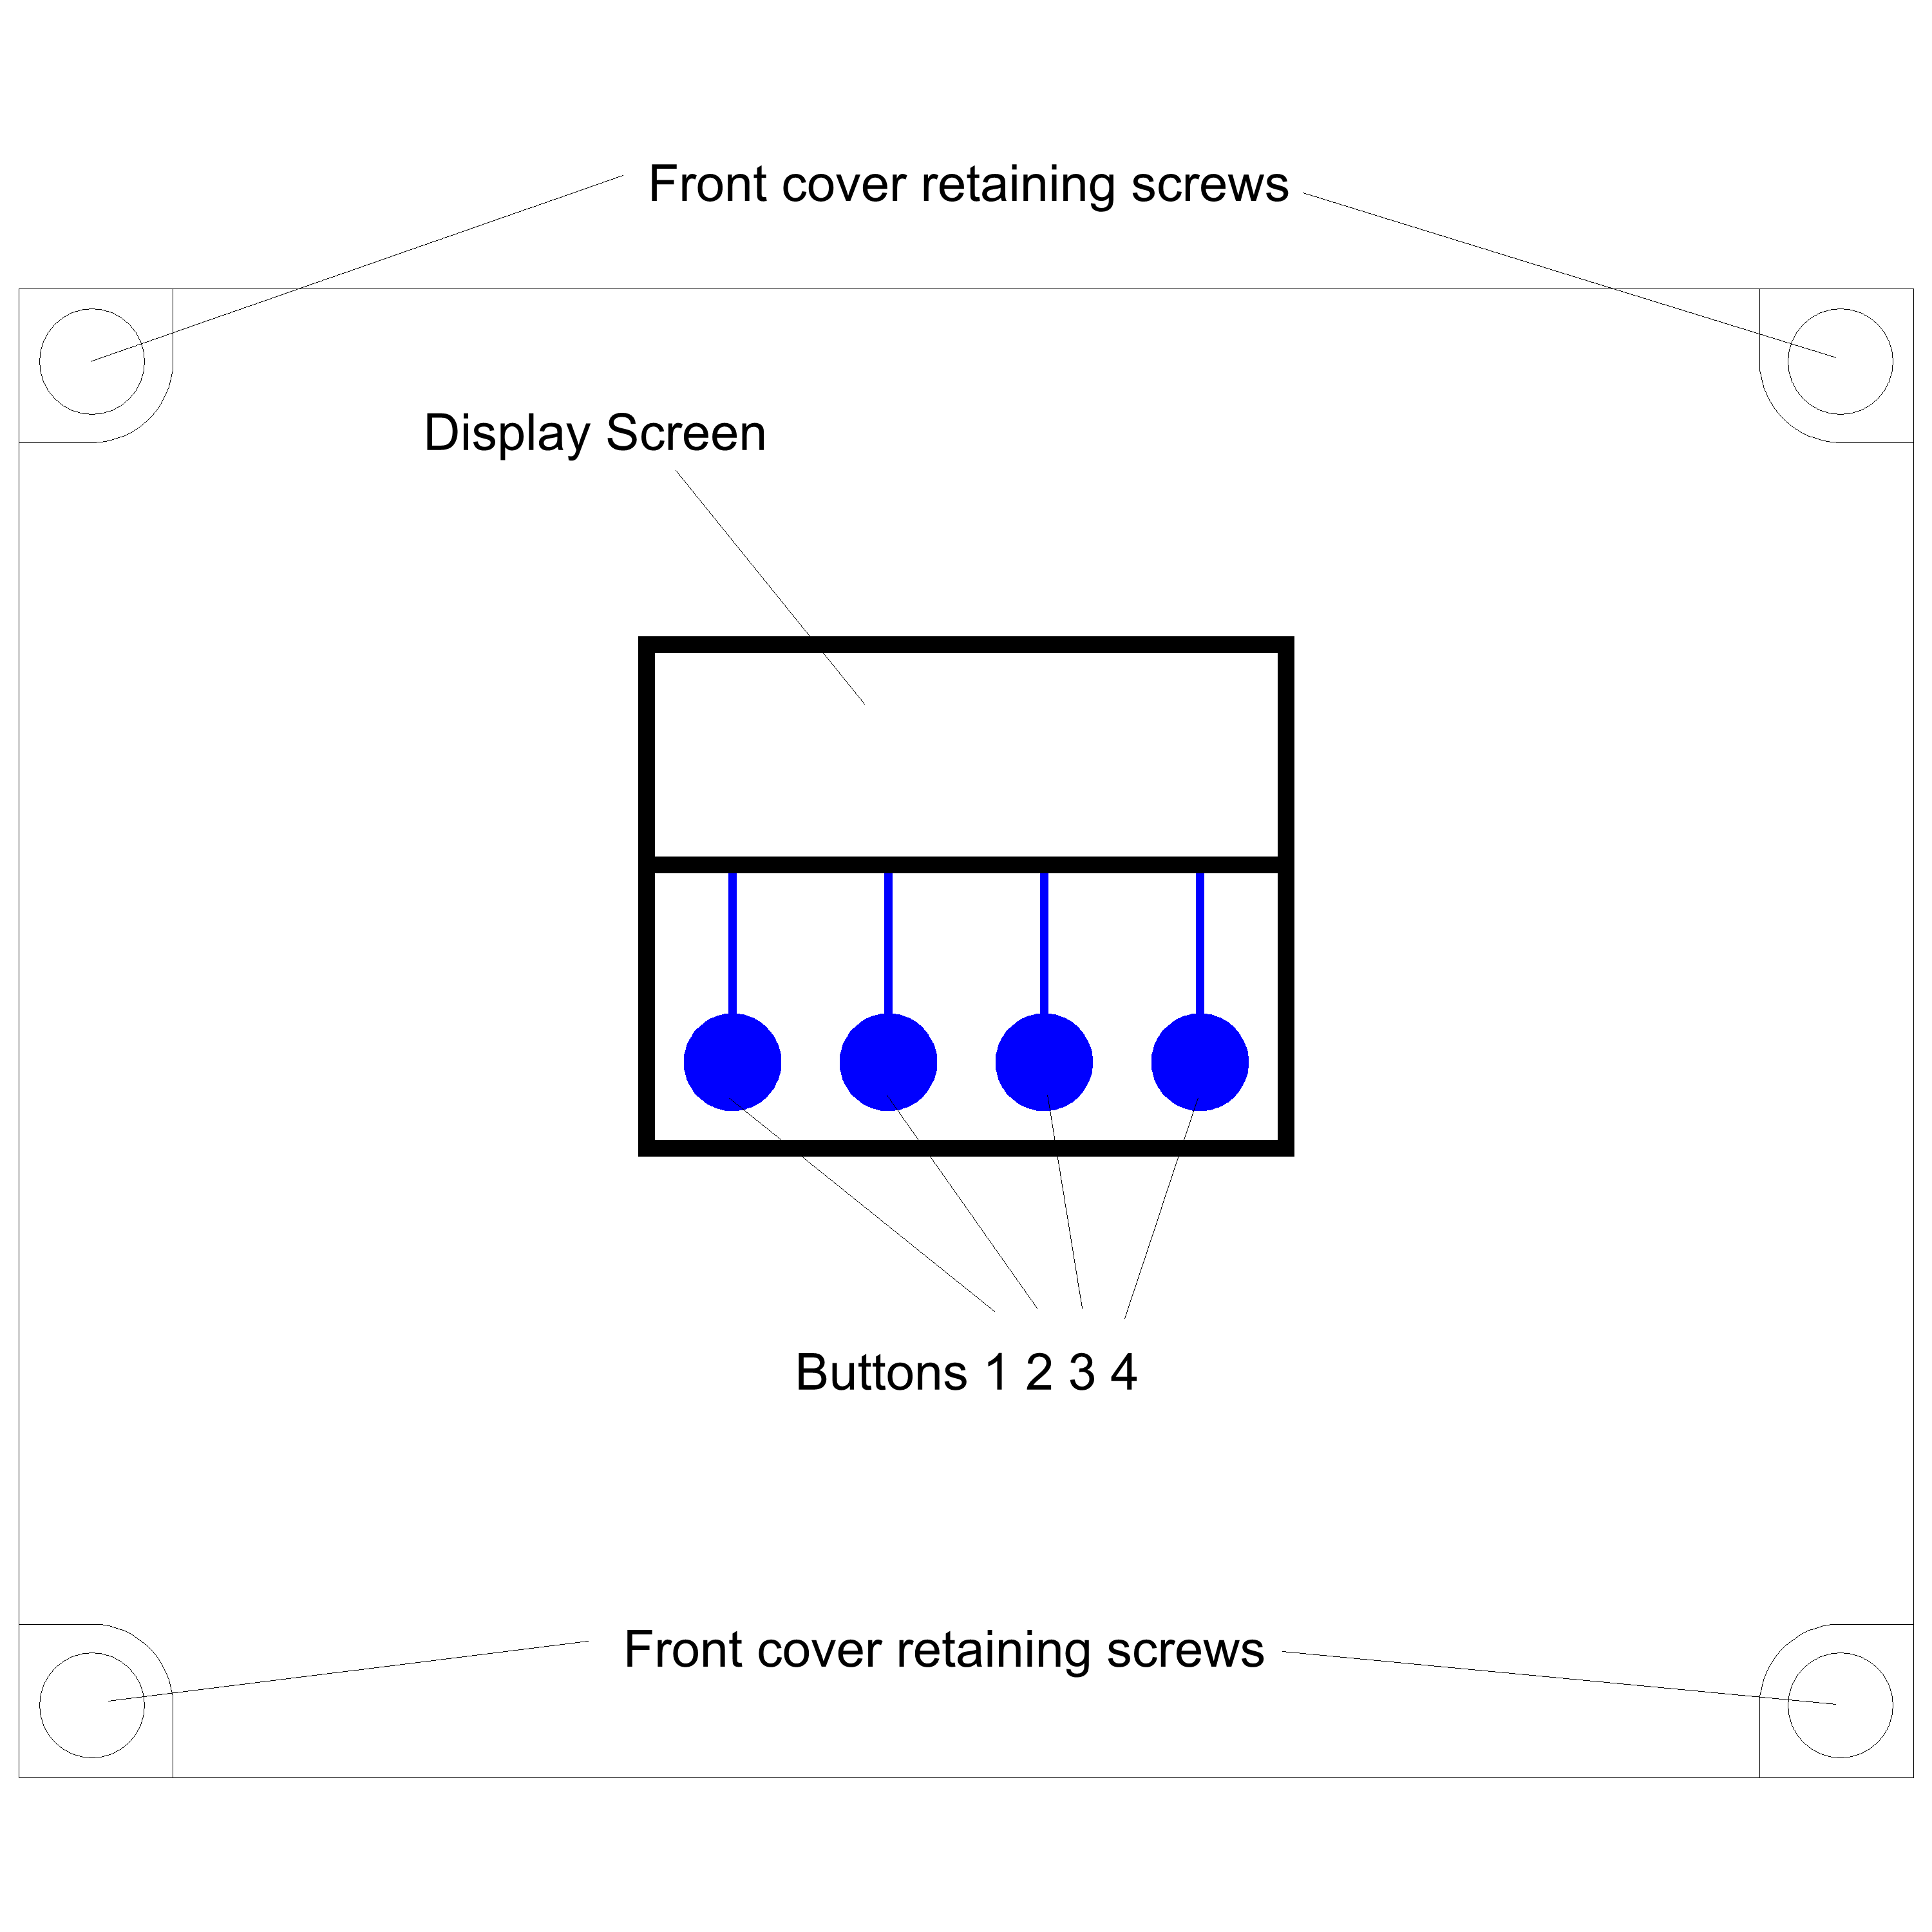
Having selected a suitable location, unlock the 4 locking screws on the corners of the front cover and withdraw the front panel. The LCD display, buttons and alarm LED are connected to the PCB. Remove and replug these cables afterwards if necessary in accordance with the diagram.
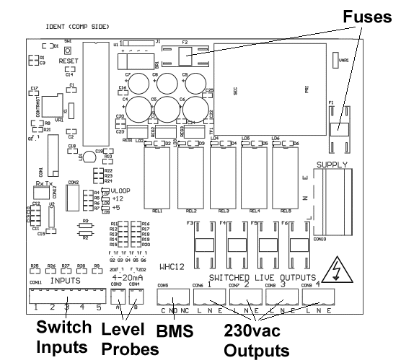
The 4 screw mounting holes are located on the main enclosure in recesses adjacent to the front panel mounting holes. Mark drilling points on the wall accordingly. Withdraw the casing from the wall and drill holes appropriate for your selected fixings.

Mains Power Connection
The power supply to the control panel enters via a cable gland on the bottom right of the housing. Insert the cable, connect to the incoming power terminal on the right of the PCB, and tighten the cable gland.

Output Power Connections
Pumps, solenoids, motirised vbalves etc. are powered from the rightmost green terminals on the lower right of the PCB. From left to right terminals 2,3,4 and 5 supply Outputs 1,2,3 and 4 (ternimal 1 is the BMS output). The terminal blocks are socketed and can be withdrawn from the PCB for ease of access.

Switch Input Connections
These inputs are used to connect switches, rain sensors or other control devices into the panel, and are used alongside the level probes to decide when to switch an output on or off.

They are connected to the 10 pin plug on the bottom left of the PCB marked “inputs” using the shielded cable provided, in the following order.

Input 1 Pins 1 and 2
Input 2 Pins 3 and 4
Input 3 Pins 5 and 6
Input 4 Pins 7 and 8
Input 5 Pins 9 and 10
Polarity is unimportant.

Note – If cables need to be routed into the controller other than with the cables glands fitted, ensure they enter the bottom of the casing and do not cross over the circuit board. If necessary use trunking to route cables appropriately.

Tank Level Sensor Connections
Connect the tank level sensor(s) to con3 and also con4 if you have a 2nd tank level sensor.

White wire to the leftmost pin of the 2 pin connector
Brown wire to the rightmost pin of the 2 pin connector
The level sensor connected to con3 is Tank 1
The level sensor connected to con4 is Tank 2 (if fitted)

Note – these inputs sense current in milliamps, don't test them by shorting them out, the input circuit will be damaged and you will have to send the board back for repair.

BMS connection
The BMS connection provides a non-voltage relay capable of switching any 230V source up to 10A. Three contacts are provided, Common, NO and NC. Connect your live conductor from the BMS system to Common, and output will be switched to NC in the absence of an alarm condition, switching to NO upon an alarm.

Troubleshooting
Refer to the Safety instructions. No electrical works should be carried out other than by an appropriately qualified Electrician. Permits to work may be required at local site conditions. If in any doubt, consult your system supplier.

Problem | Probable Cause | Solutions
No Power – controller dead – no backlight on LCD | No power supply from distribution board  Fuse failed  PCB damaged | Check 240 vac 50hz supply at power input terminals.  Check Fuse F1  Replace PCB, contact manufacturer.
Backlight on – no display – no operation | CPU chip missing  CPU chip badly inserted or bent pins  CPU chip wrong way round  CPU chip faulty  PCB damaged | Insert CPU  Insert CPU correctly or replace if necessary  Remove and re-insert correctly  Replace CPU  Replace PCB, contact manufacturer.
Controller Frozen – operates normally but keypad unresponsive | Keypad not connected or connected wrong | Check connection, try reversing connector direction
Controller Frozen – does not operate normally | CPU or oscillator damaged | Replace CPU, if no success replace PCB
Switch input appears not to function | Not connected  Cable damaged  Float switch not constrained properly  Float faulty | Check connection to control panel  Test continuity, replace if necessary  Tie float in tank such that it switches up/down around switch point  Replace
Tank level sensor does not function | Not connected  Connected wrongly  Sensor faulty  Input circuit faulty | Check wiring to controller  Check wiring polarity and correct if needed  Test with loop calibrator, replace sensor if necessary  Test with loop calibrator, replace PCB if necessary
Tank Level sensor reads incorrectly | Cable vent tube blocked or sealed  Wrong sensor specification installed  Sensor faulty | Ensure vented section of cable terminates to atmospheric pressure  Replace with original OEM spec part  Test with loop calibrator, replace if necessary
Header tank overflow detected (error 10) | Sensor installed wrong way up  Sensor installed too low  High level sensor failure causes overflow  Solenoid stuck open | Check orientation, toggle should hang downward.  Relocate above other sensors  Test and replace sensor  Isolate power, test and replace solenoid

Note – References to loop calibrator refer to a current loop calibrator 4-20mA, NOT a loop impedance test.

Fuse Listing

F1 – 500mA 20mm quickblow
F2 – 1A 20mm glass passivated
F3 – 10A 20mm glass passivated
F4 – 10A 20mm glass passivated
F5 – 10A 20mm glass passivated
F6 – 10A 20mm glass passivated

Inputs (left to right) – Con1

1 – Switch 1
2 – Switch 2
3 – Switch 3
4 – Switch 4
5 – Switch 5

Pressure Sensor Inputs (left to right)

Con3 (left) – Tank 1 Level Sensor
Con4 (right) – Tank 2 Level Sensor

BMS Output

Type – Non contact relay
Terminals – Common, Normally Open, Normally Closed
Power Rating max 10A 230Vac

Output Control Outputs (left to right)

1 – Output 1
2 – Output 2
3 – Output 3
4 – Output 4

Upgrades and Modifications

The following parts of the system can be upgraded at any time without any modification to the control panel.

Replacement/upgrade of pump(s)
Replacement/upgrade of solenoid(s)

Note – there is no need to reprogram or adjust the control panel settings when replacing a pump with one of a different power output or consumption. Diagnostic functions are not dependent on current monitoring.

Installation of 3 phase pump(s) via external contactor/relay.

Software upgrade by either on-site reprogramming, or by CPU replacement. Reprogramming is unlikely to ever be necessary, but is provided for to allow for custom software to be retrofitted to the control panel. It is carried out by an approved engineer via an on-board programming port, or via replacement of the CPU. The CPU is socketed in a 40pin DIP socket for ease of replacement. The CPU is a

When replacing the CPU, always use a proper DIP Extraction Tool, and follow the instruction provided with the replacement CPU.

Specifications

Control Panel
Dimensions 240mm x 190mm x 110mm
Supply Voltage 230-240 Vac 50Hz
Power Consumption 7w (Control Panel Only)
Operating temperature range 0 to 40 degrees celsius
Ingress protection IP66 (IP68 available on request)

Tank Level Sensor
Type Pressure Transmitter 2 wire
Measurement Range 0-0.6 bar
Input 8 to 30 Vdc
Output 4-20mA

Switched Outputs (pump/solenoid/valve control)
Voltage 230-240vac 50hz (exact voltage as supply voltage)
Current 10A (peak 16A)

Operation

Description of Operation

The 3P TC Series Tank Controller is a fluid level control system which maintains the water level in a tank between 2 set points (adjustable) by switching on pumps, solenoid valves, or any other connected devices to fill or drain the tank as needed. It is a microprocessor based unit and senses water depth using a piezo electric pressure sensor.

This type of solution provides vast improvements in reliability when compared with traditional panel built systems based on float switches, along with reduced installation time, easy reconfiguration, reduced maintenance, and smaller space requirements within the plant room.

The upper and lower set points and function of devices within the tank are easily set from the control panel without the need to access the rainwater tank.

Control of attached devices is provided via direct mains voltage outputs from the control panel in single phase, operating as necessary within the level set points specified by the user. Pumps, solenoids, motorised valves and sluices can all be controlled automatically to add or remove fluid to achieve the desired level. Multiple appliances can be used within the same tank.

Contactors or relays can be used to allow control of 3 phase, or low voltage devices.

Outputs can be assigned as Fill or Drain types, and are each set a level range between which to operate. Each output can be assigned to one probe, and up to 5 switched inputs and 2 virtual inputs to provide further qualification for activation. For example, a pump could be assigned to drain a tank upon reaching a certain level only if a reed switch at the destination tank reports it as not being already full, or perhaps to supply water to an outlet only if a pressure switch on that line shows low pressure.

Virtual I/O consists of inputs and outputs that don't physically exist, you can't connect wires to them as there are no terminals, but a virtual output is connected logically to a corresponding virtual input. In fact, the output and input are just two ways of visualizing the same object in the software. By setting a virtual output to trigger on certain levels and inputs from one tank and then using it as an input for the other, the behaviors of both tanks can be made interdependent.

For attenuation systems, the use of a pressure based sensor allows for a very wide band of operation between cut-in and cut-out levels. The ability to operate different pumps with different purposes independently in the same tank easily allows you to configure combined harvesting/attenuation systems, or add a high level pumped overflow without additional control equipment.

Control Panel Operations

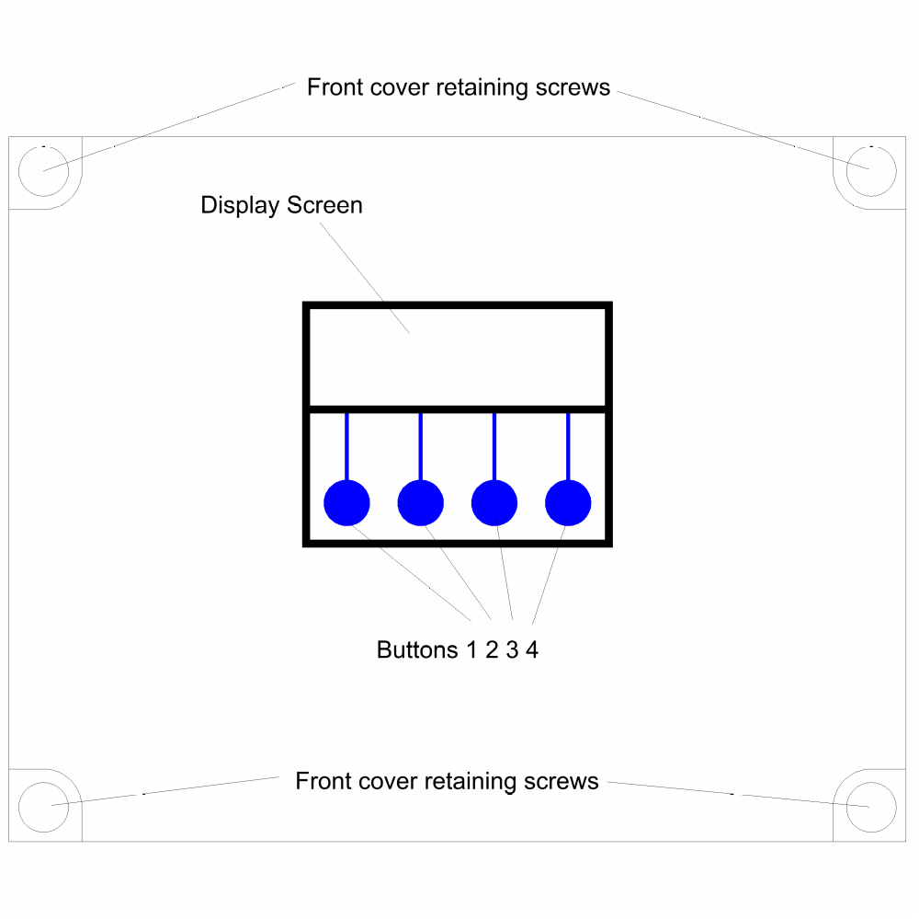

Menus and Functions

Upon first applying power, the LCD panel will display a startup logo followed by automatic setting of default parameters. In this state all outputs are unassigned, the panel will show the water level for tanks 1 and 2. If a probe for either tank is not connected it will show as empty.

Water level is displayed in cm, unlike other versions of this panel which read a percentage the TC Series controller is concerned only with absolute levels, not relative capacity.

Water Level Display
The current water level for each tank will be shown in cm. Where no probe is attached the corresponding tank level will not be shown.

Note that if an output has been set to use a probe which is not present, a fault will be registered accordingly as that probe will be assumed to be faulty, or unintentionally disconnected. If no outputs are set to use a particular probe, then it's absence will not be registered as a fault.

Accessing the Menu Options
The last line of the display always shows up to four menu options, which can be selected by pressing one of the four corresponding buttons beneath the display. The menu options displayed will change as you enter different areas of the software.

Status Screen
This is the screen that will show during normal operation, and is where the system defaults to after power-on. While this screen is showing the system operates as normal, water level displays are continuously updated and any outputs which have been configured will operate as needed.

Note that if MENU or STOP are pressed, all operation will halt until the user returns to this main status screen. The operator must therefore decide whether halting the system for configuration is appropriate and for how long.

Main Menu
3 options are available,
Setup – allows the operator to configure the operation of the system.
Diags (Diagnostics) – Allows the user to review and clear any logged faults from the system, test the status of all inputs and test all outputs.
Run – returns to the main status screen and resumes operation.

Setup Menu (Menu>Setup)

4 options are available
Virtual – sets the conditions that will operate each virtual output.
Outputs – sets the conditions that will operate each physical output.
Alarms – sets high and low level alarm levels for each tank which will trigger the BMS output.
Exits – returns to the Main Menu.

Virtual Output Setup (Menu>Setup>Virtual)
Unless you are controlling 2 tanks and want an output to operate depending on the conditions in both tanks this setting can be skipped.

3 options are available :-
I/O 1 – sets the range for probe 1 – currently this function is unused.
I/O 2 – sets the range for probe 2 – currently this function is unused.
Stability – sets the sensitivity of the probe, used to compensate for false changes in level reading caused by incorrect probe location or turbulence during filling.
Exit – returns to the Setup Menu.

Output Setup (Menu>Setup>Outputs)
This menu allows you to select one of 4 outputs to configure. Once selected 2 screens will be shown, the first allowing the output to be set to either fill of drain the tank, use either probe and any combination of 5 switched inputs. The second screen will allow the setting of the minimum and maximum levels in the tank which it will maintain.

Main Functions
The options on the first screen are as follows

Button 1 will select either Off, Fill, or Drain. A solenoid filling a storage tank for example would be set as a Fill device, wheras a drainage pump would be a Drain device.

Button 2 Selects which probe, and hence which tank the output will be operating with. This does not mean the device has to be in that tank but usually this will be the case. A transfer pump in tank 1 pumping to tank 2 could be set as either a Drain type device operating on probe 1, or a Fill type device operating on probe 2, whichever is most appropriate.

Button 3 selects one or more of 5 switched inputs which must be closed in order for the output to operate. This condition is in addition to the trigger levels being reached.

Button 4 takes you to the virtual input selection screen.

Virtual Input Selection
, where in addition to the input switches sleected previously you can also select either or both of the 2 virtual inputs (these are triggered by the virtual outputs). Button 1 selects these inputs and button 4 moves on to the next screen to set the operating levels for this output.

Levels
In this screen buttons 1 and 2 adjust the level up and down, and button 3 selects adjustment of either the minimum or maximum level. The minimum and maximum levels cannot be set closer than 3cm from each other, nor can they overlap. If you try to set the minimum level as high as the maximum, the maximum will increase itself. If you try to set the maximum level down to the minimum level it will stop 3cm above that level. Button 4 then proceeds to the Duty Cycle selection screen.

Duty Cycle
Here you are able to select the duty cycle for the output you are configuring. Each output can operate from 1 to 100% duty cycle (default setting is 100%) operating in 10 minute periods. So a duty cycle of 30% would result in the output, when activated, running for 3 minutes then pausing for 7 minutes every 10 minutes.
When used in conjunction with the known flow rate of a pump or valve, duty cycling can be used to reduce the flow rate of an output to a specified maximum.

Output Configuration Examples

Example 1 - A solenoid maintaining a 2 metre deep storage tank 1 with mains water

Output 1
Type Probe Switch
Fill 1 none Next

Output 1 – Levels
Min Max
172cm 198cm
- + Min Exit

Explanation – Fill tank 1 when the water drops to 172cm, stop when it reaches 198cm. The solenoid would not operate until the level drops to 172cm or less, but once activated will not stop until the level reaches it's high set point of 198cm.

Example 2 - 2 drainage pumps pumping surface water from a sump tank

Output 1
Type Probe Switch
Drain 1 none Next

Output 1 – Levels
Min Max
52cm 75cm
- + Min Exit

Output 2
Type Probe Switch
Drain 1 none Next

Output 2 – Levels
Min Max
52cm 90cm
- + Min Exit

Explanation – the pump on output 1 will activate when the level in tank 1 reaches or exceeds 75cm and will stop once the level is reduced to 52cm. If the level increases beyond the capacity of this pump, the pump on output 2 will activate at 90cm, also not stopping until the level reduces to 52cm. This is Duty Assist/Duty Standby without alternation.

Example 3 - A direct feed rainwater harvester, using a solenoid on output 1 for mains water back up, a supply pump on output 2 and a pressure switch on switched input 1 to signal the pump to supply water.

Output 1
Type Probe Switch
Fill 1 none Next

Output 1 – Levels
Min Max
75cm 90cm
- + Min Exit

Output 2
Type Probe Switch
Drain 1 1 Next

Output 2 – Levels
Min Max
30cm 33cm
- + Min Exit

Explanation – the pump will operate as long as there is 33cm of more of water and the pressure switch (normally closed at low pressure) is closed. The level cannot drop below 30cm, protecting the pump from running dry, and as long as mains water is available will not drop below 75cm. Note that the mains back up is set to only supply 15cm of water, so as not to use mains water unnecessarily.

Tank Alarms (Menu>Setup>Alarms)
This menu contains the settings for the high and low level alarms for each tank/probe. Once either of these levels is exceeded, the BMS output will be activated, the red alarm LED on the panel will illuminate, and a fault code will be stored.

The high and low alarm levels for a tank should of course be set beyond the normal operating levels of the devices filling or draining the tank.

Fault Diagnosis

Diagnostic Menu (Menu>Diags)
This menu provides diagnostic options including the ability to view the state of all inputs, activate the outputs, manually, compensate for level probe instability problems, and view any high or low level alarm events that may have occurred.

Input Options (Menu>Diags>Inputs)
From this menu you can select whether you want to view or adjust inputs, activate or test outputs, or view and clear faults previously logged.

View Inputs (Menu>Diags>Inputs>View Input)
In this screen you will be presented with an overview of the status of all 5 switch inputs, and the current detected by the analogue level sensor inputs in MilliAmps.

Switches 10111
Tank 1 12.0 mA
Tank 2 0.0 mA
Exit

The above screen shows firstly the status of the 5 digital inputs (switches), where 1 = not closed and 0 = closed. In this example switch 2 is closed, all the others are open.

Below this is the current detected at the analogue level sensor inputs. The sensor supplied operates from 4 to 20mA and ranges from 0 to 6m in depth, so a reading of 4mA would indicate an empty tank, and 20mA would indicate 6 metres of water above the sensor. As there is a normal range of 16mA between empty and full each mA above 4mA (zero level) is equal to 6000/16 = 375mm, and each 1/10th mA is 37.5mm. 12MA as shown here is halfway between empty and full (4 and 20) and thus should equate a level of 3m depth.

A connected probe which is not submerged should read 4.0mA, and where there is no connection at all to the input you should see 0.0mA.

An instrumentation technician can connect a Current Loop Calibrator (NOTE – NOT an electricians loop impedance meter) to these inputs to test the input circuit. The loop is powered from the control panel at +15vdc.

DO NOT SHORT THE ANALOGUE INPUT WITH A WIRE, this will destroy the diode above the input socket which will then have to be replaced. The 5 Digital (Switch) inputs however can be tested this way.

Adjust Probe Stability (Menu>Diags>Inputs>Adjust Probe Stability)
Here you can compensate for instability in the level readings caused by induced RF interference from nearby equipment, or by sudden shock, movement or aeration of the fluid itself (a large solenoid valve opening).

Under normal conditions, each probe is read at approximately 10ms intervals and this reading used to operate outputs, alarms, etc. The stability adjustment can be set to reads the probe several times and take an average value as the final reading, this is known as oversampling.

The default setting is 1 (read the level once and take action, every 10ms)

The maximum setting is 100 (read the level 100 times at 10ms intervals, and act upon the average reading every 10s)

There is of course a trade off between the accuracy gained from taking several readings, and the response time of the controller. In a tank that takes an hour to fill or empty it may make little difference, but if a tank fills in minutes or seconds, a 10 second delay could have unintended consequences.

We recommend this feature therefore be used only when needed, and be aware then every increment in this setting adds 10ms to the response time of your outputs and alarms.

Activate Outputs (Menu>Diags>Outputs)
A simple diagnostic function where you can press each of the 4 buttons to activate and turn off each of the 4 outputs, either to test connected equipment, or to test each output is functioning correctly.

Output Testing
0000
Push buttons...
Hold 1+4 to reset

0 means off, 1 means on. To exit you need to press buttons 1 and 4 together.

View Logged Fault Codes (Menu>Diags>Faults)
This screen displays the last 10 faults the system has detected.

Due to the multi-purpose design of this control panel, faults are only generated by the water level exceeding the high or low level alarms, or a failure of a probe assigned to an output function. To assist in diagnosis, a fault based on an alarm level has several possible codes indicating which outputs were switched on at the time of the fault. So while there are 66 fault codes, only 6 events will actually trigger a fault, these are

Low Level Alarm – Tank 1
High Level Alarm – Tank 1
Low Level Alarm – Tank 2
High Level Alarm – Tank 2
Probe Failure – Tank 1
Probe Failure – Tank 2

A probe failure is triggered by either an open circuit connection to the probe, or an implausibly low level reading (less than 0).

This provides a snapshot of system activity at the time of the fault allowing the operator greater insight into the actual cause of the fault.

TC Series Fault Codes (all models)

Code Fault Active Outputs
1 2 3 4
0 | High Level Alarm – Tank 1
1 | High Level Alarm – Tank 2
2 | High Level Alarm – Tank 1 | On
3 | High Level Alarm – Tank 2 | On
4 | High Level Alarm – Tank 1 |  | On
5 | High Level Alarm – Tank 2 |  | On
6 | High Level Alarm – Tank 1 | On | On
7 | High Level Alarm – Tank 2 | On | On
8 | High Level Alarm – Tank 1 |  |  | On
9 | High Level Alarm – Tank 2 |  |  | On
10 | High Level Alarm – Tank 1 | On |  | On
11 | High Level Alarm – Tank 2 | On |  | On
12 | High Level Alarm – Tank 1 |  | On | On
13 | High Level Alarm – Tank 2 |  | On | On
14 | High Level Alarm – Tank 1 | On | On | On
15 | High Level Alarm – Tank 2 | On | On | On
16 | High Level Alarm – Tank 1 |  |  |  | On
17 | High Level Alarm – Tank 2 |  |  |  | On
18 | High Level Alarm – Tank 1 | On |  |  | On
19 | High Level Alarm – Tank 2 | On |  |  | On
20 | High Level Alarm – Tank 1 |  | On |  | On
21 | High Level Alarm – Tank 2 |  | On |  | On
22 | High Level Alarm – Tank 1 | On | On |  | On
23 | High Level Alarm – Tank 2 | On | On |  | On
24 | High Level Alarm – Tank 1 |  |  | On | On
25 | High Level Alarm – Tank 2 |  |  | On | On
26 | High Level Alarm – Tank 1 | On |  | On | On
27 | High Level Alarm – Tank 2 | On |  | On | On
28 | High Level Alarm – Tank 1 |  | On | On | On
29 | High Level Alarm – Tank 2 |  | On | On | On
30 | High Level Alarm – Tank 1 | On | On | On | On
31 | High Level Alarm – Tank 2 | On | On | On | On
32 | Low Level Alarm – Tank 1
33 | Low Level Alarm – Tank 2
34 | Low Level Alarm – Tank 1 | On
35 | Low Level Alarm – Tank 2 | On
36 | Low Level Alarm – Tank 1 |  | On
37 | Low Level Alarm – Tank 2 |  | On
38 | Low Level Alarm – Tank 1 | On | On
39 | Low Level Alarm – Tank 2 | On | On
40 | Low Level Alarm – Tank 1 |  |  | On
41 | Low Level Alarm – Tank 2 |  |  | On
42 | Low Level Alarm – Tank 1 | On |  | On
43 | Low Level Alarm – Tank 2 | On |  | On
44 | Low Level Alarm – Tank 1 |  | On | On
45 | Low Level Alarm – Tank 2 |  | On | On
46 | Low Level Alarm – Tank 1 | On | On | On
47 | Low Level Alarm – Tank 2 | On | On | On
48 | Low Level Alarm – Tank 1 |  |  |  | On
49 | Low Level Alarm – Tank 2 |  |  |  | On
50 | Low Level Alarm – Tank 1 | On |  |  | On
51 | Low Level Alarm – Tank 2 | On |  |  | On
52 | Low Level Alarm – Tank 1 |  | On |  | On
53 | Low Level Alarm – Tank 2 |  | On |  | On
54 | Low Level Alarm – Tank 1 | On | On |  | On
55 | Low Level Alarm – Tank 2 | On | On |  | On
56 | Low Level Alarm – Tank 1 |  |  | On | On
57 | Low Level Alarm – Tank 2 |  |  | On | On
58 | Low Level Alarm – Tank 1 | On |  | On | On
59 | Low Level Alarm – Tank 2 | On |  | On | On
60 | Low Level Alarm – Tank 1 |  | On | On | On
61 | Low Level Alarm – Tank 2 |  | On | On | On
62 | Low Level Alarm – Tank 1 | On | On | On | On
63 | Low Level Alarm – Tank 2 | On | On | On | On
128 | Probe Failure – Tank 1 | - | - | - | -
129 | Probe Failure – Tank 2 | - | - | - | -

Clear Logged Fault Codes (Menu>Diags>Faults>Clear)
Selecting this option deletes all stored fault codes.

Run
Returns to the main screen and resumes operation.

Stop
At any time while the system is running (i.e. not in a menu setting), the operation of the panel, pumps and solenoid can be halted by pressing STOP. Unlike pressing Menu, this option will activate the BMS output to indicate that the unit has been halted for a purpose other than configuration. It is expected that this button may be used by persons with no knowledge of the system and/or no access to the Operation Manual. Under this setting there are 3 options.

Menu (Stop>Menu)
Enters the main system menu (see 3.3), thus allowing fault to be inspected and cleared.

Wipe Configuration (Stop>Wipe Config)
This option wipes all configuration settings from memory then restarts the system. Default values will then be loaded and the system will behave as if it were switched on for the first time. NOTE – Any options set during commissioning will be lost and need to be re-entered.

Restart (Stop>Restart)
Restarts operation of the system. The BMS output will be de-activated and normal operation will resume.

Troubleshooting
Refer to the Safety instructions. No electrical works should be carried out other than by an appropriately qualified Electrician. Permits to work may be required at local site conditions. If in any doubt, consult your system supplier.

Problem | Probable Cause | Solutions
No Power – controller dead – no backlight on LCD | No power supply from distribution board  Fuse failed  PCB damaged | Check 240 vac 50hz supply at power input terminals.  Check Fuse F1  Replace PCB, contact manufacturer.
Backlight on – no display – no operation | CPU chip missing  CPU chip badly inserted or bent pins  CPU chip wrong way round  CPU chip faulty  PCB damaged | Insert CPU  Insert CPU correctly or replace if necessary  Remove and re-insert correctly  Replace CPU  Replace PCB, contact manufacturer.
Controller Frozen – operates normally but keypad unresponsive | Keypad not connected or connected wrongly | Check connection
Controller Frozen – does not operate normally | CPU or oscillator damaged | Replace CPU, if no success replace PCB
Float switch appears not to function | Not connected  Cable damaged  Float not constrained properly  Float faulty | Check connection to control panel  Test continuity, replace if necessary  Tie float in tank such that it switches up/down around switch point  Replace
Tank level sensor does not function (fault 128 or 129) | Not connected  Connected wrongly  Sensor faulty  Input circuit faulty | Check wiring to controller  Check wiring polarity and correct if needed  Test with loop calibrator, replace sensor if necessary  Test with loop calibrator, replace PCB if necessary  DO NOT – Bridge the sensor input with wire, this will destroy the input circuit!
Tank Level sensor reads incorrectly | Cable vent tube blocked or sealed  Wrong sensor specification installed  Sensor faulty  Parasitic interference from nearby cables | Ensure vented section of cable terminates to atmospheric pressure  Replace with original OEM spec part  Test with loop calibrator, replace if necessary  Ensure cable is shielded all the way OR Separate sensor cable from lighting and motor supply cables OR adjust probe sensitivity setting to compensate

NOTE – A loop calibrator is used for testing sensors and sensor inputs by drawing or measuring between 4mA and 20mA of current. Do not confuse this with an electricians loop impedance tester, which is designed to measure the impedance of the mains electrical supply system. Do not confuse this either with shorting the input with a piece of wire (sometimes referred to wrongly as a “loop test”), this will damage the input circuit.

Fuse Listing
F1 – 500mA 20mm quickblow
F2 – 1A 20mm glass passivated
F3 – 10A 20mm glass passivated
F4 – 10A 20mm glass passivated
F5 – 10A 20mm glass passivated
F6 – 10A 20mm glass passivated

Inputs (left to right) – Con1
1 – Switched Input 1
2 – Switched Input 2
3 – Switched Input 3
4 – Switched Input 4
5 – Switched Input 5

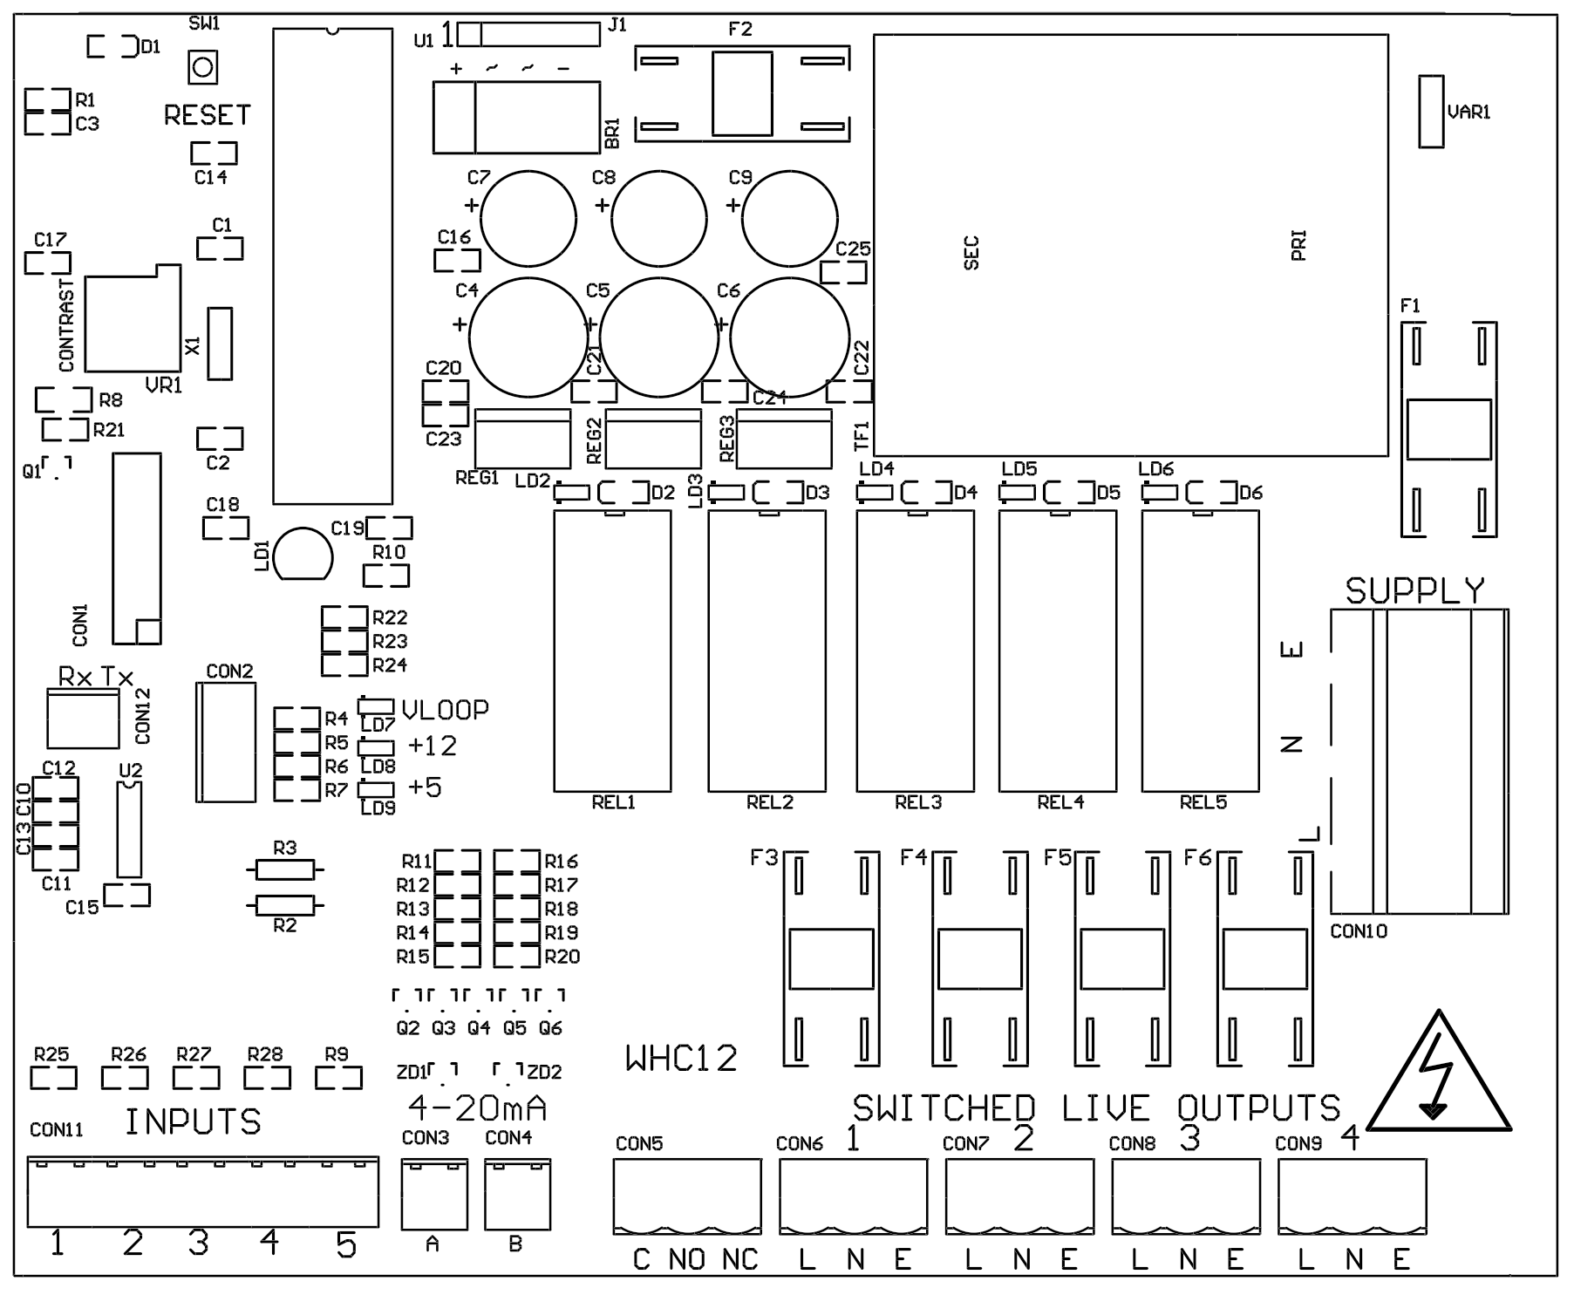
Each switched input is also designed to operate correctly with 3P Technik conductivity probes

Pressure Sensor Inputs (left to right)
Con3 (left) – Tank 1 Level Sensor
Con4 (right) – Tank 2 Level Sensor

BMS Output (con5)
Type – Non contact relay
Terminals – Common, Normally Open, Normally Closed
Power Rating max 10A 230Vac

Outputs (left to right)
1 – Top-up solenoid(s)
2 – (reserved for future upgrade)
3 – Pump1
4 – Pump2

Outputs supply mains voltage AC electricity at 230v nominal to connected equipment. Live is switched, Earth and Neutral are permanently connected.

RCDs, Timers, Over/Under voltage relays, Earth Leakage Devices, Contactors and Thermal Overload Relays may be connected to these outputs to provide 3 phase operation, additional protection and/or funcionality.

Upgrades and Modifications
The following parts of the system can be upgraded at any time without any modification to the control panel.

Replacement/upgrade of pump(s)
Replacement/upgrade of solenoid(s) or motorised valve(s)
Replacement of Level Probe, Switch or other input device.

Note – there is no need to reprogram or adjust the control panel settings when replacing a pump with one of a different power output or consumption. Diagnostic functions are not dependent on current monitoring.

Installation of 3 phase pump(s) via external contactor/relay.

When extending a probe or sensor cable a shielded and vented sensor cable must be used, otherwise the level display reading and hence operation based on levels will be inaccurate.
DO NOT use mains flex, FP200, twin & earth, network cable, etc.

Software upgrade by either on-site reprogramming, or by CPU replacement. Reprogramming is unlikely to ever be necessary, but is provided for to allow for custom software to be retrofitted to the control panel. It is carried out by an approved engineer via an on-board programming port, or via replacement of the CPU. The CPU is socketed in a 40pin DIP socket for ease of replacement.

When replacing the CPU, always use a proper DIP Extraction Tool, and follow the instruction provided with the replacement CPU.

Specifications

Control Panel
Dimensions 240mm x 190mm x 110mm
Supply Voltage 230-240 Vac 50Hz
Power Consumption 7w (Control Panel Only)
Operating temperature range 0 to 40 degrees celsius
Ingress protection IP66

Tank Level Sensor
Type Pressure Transmitter 2 wire
Measurement Range 0-0.6 bar
Input 8 to 30 Vdc
Output 4-20mA

Switched Outputs (pump/solenoid control)
Voltage 230-240vac 50hz (exact voltage as supply voltage)
Current 10A (peak 16A)

